U.S. Citizenship Act 2021
SEC. 4203. FUNDING TO SCHOOL DISTRICTS FOR UNACCOMPANIED NONCITIZEN CHILDREN.
(a) GRANTS AUTHORIZED —The Secretary of Education shall award grants, on a competitive basis, to eligible local educational agencies or consortia of neighboring local educational agencies described in subsection (b), to enable the local educational agencies or consortia to enhance opportunities for, and provide services to, immigrant children, including unaccompanied noncitizen children, in the area served by the local educational agencies or consortia.
(b) ELIGIBLE LOCAL EDUCATIONAL AGENCIES —
(1) IN GENERAL —A local educational agency or a consortium of neighboring local educational agencies is eligible for a grant under subsection if, during the fiscal year for which a grant is awarded under this section, there are 50 or more unaccompanied noncitizen children enrolled in the public schools served by the local educational agency or the consortium.
(2) DETERMINATIONS OF NUMBER OF UNACCOMPANIED NONCITIZEN CHILDREN —The Secretary of Education shall determine the number of unaccompanied noncitizen children for purposes of paragraph (1) based on the most accurate data available that is provided to the Secretary of Education by the Director of the Office of Refugee Resettlement or the Department of Homeland Security.
(c) APPLICATIONS.—A local educational agency or a consortia of neighboring local educational agencies desiring a grant under this section shall submit an application to the Secretary of Education at such time, in such manner, and containing such information as the Secretary of Education may require, including a description of how the grant will be used to enhance opportunities for, and provide services to, immigrant children and youth (including unaccompanied noncitizen children) and their families.
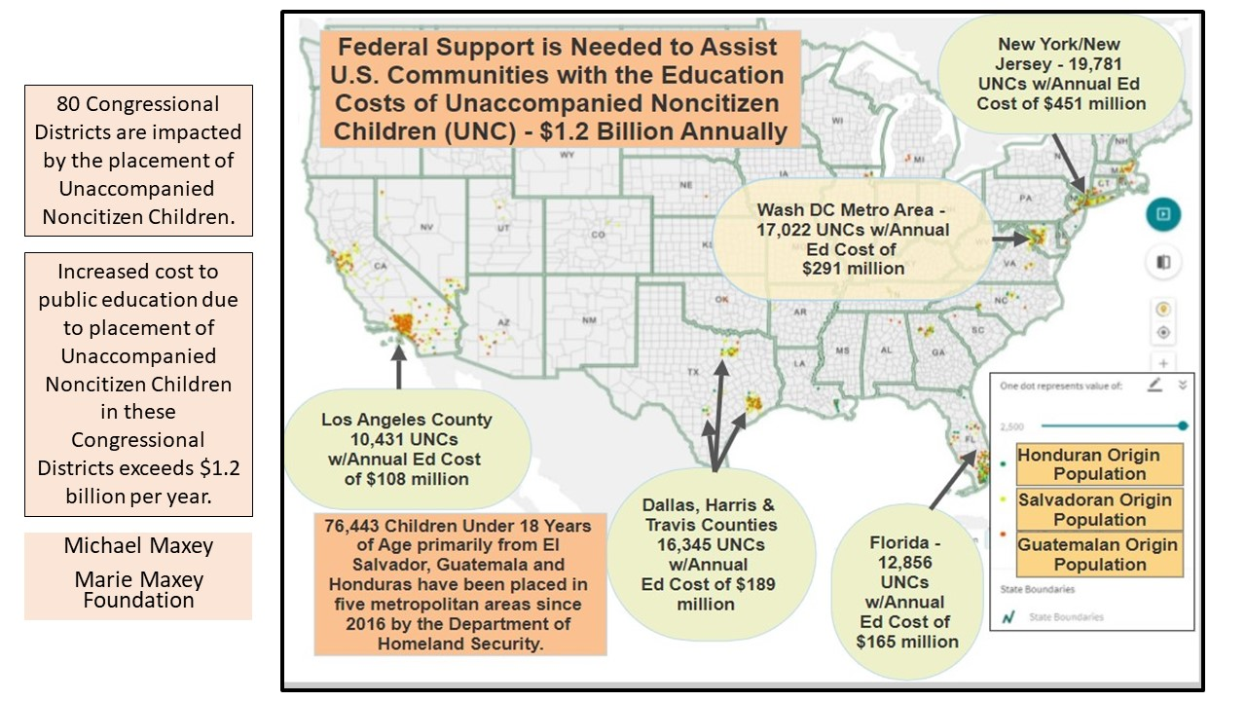
H.R. 117 – U.S. Citizenship Act
Cosponsor Date Cosponsored Chief of Staff
Rep. Lofgren, Zoe [D-CA-19]* 02/18/2021 Stacey Leavandosky
Rep. Roybal-Allard, Lucille [D-CA-40]* 02/18/2021 Victor Castillo
Rep. Velazquez, Nydia M. [D-NY-7]* 02/18/2021 Justin Pelletier
Rep. Clarke, Yvette D. [D-NY-9]* 02/18/2021 Charlyn Stanberry
Rep. Bass, Karen [D-CA-37]* 02/18/2021 Darryn Harris
Rep. Chu, Judy [D-CA-27]* 02/18/2021 Sonali Desai
Rep. Ruiz, Raul [D-CA-36]* 02/18/2021 Tim Del Monico
Rep. Napolitano, Grace F. [D-CA-32]* 02/18/2021 Daniel Chao
Rep. Espaillat, Adriano [D-NY-13]* 02/18/2021 Aneiry Batista
Rep. Carbajal, Salud O. [D-CA-24]* 02/18/2021 Jeremy Tittle
Rep. Vargas, Juan [D-CA-51]* 02/18/2021 Scott Hinkle
Rep. Gomez, Jimmy [D-CA-34]* 02/18/2021 Bertha Guerrero
Rep. Gallego, Ruben [D-AZ-7]* 02/18/2021 David Montes
Rep. Correa, J. Luis [D-CA-46]* 02/18/2021 Laurie Saroff
Rep. Aguilar, Pete [D-CA-31]* 02/18/2021 Becky Cornell
Rep. Escobar, Veronica [D-TX-16]* 02/18/2021 Eduardo Lerma
Rep. Garcia, Sylvia R. [D-TX-29]* 02/18/2021 John Gorczynski
Rep. Cardenas, Tony [D-CA-29]* 02/18/2021 Miguel Franco
Rep. Leger Fernandez, Teresa [D-NM-3]* 02/18/2021 Angela Ramirez
Rep. Castro, Joaquin [D-TX-20]* 02/18/2021 Danny Meza
Rep. Barragan, Nanette Diaz [D-CA-44]* 02/18/2021 Francisco Carrillo
Rep. Vela, Filemon [D-TX-34]* 02/18/2021 Sandra Alcala
Rep. Soto, Darren [D-FL-9]* 02/18/2021 Christine Biron
Rep. Levin, Mike [D-CA-49]* 02/18/2021 Kara Van Stralen
Rep. Costa, Jim [D-CA-16]* 02/18/2021 Juan Lopez
Rep. Torres, Ritchie [D-NY-15]* 02/18/2021 ----
Rep. Sires, Albio [D-NJ-8]* 02/18/2021 Gene Martorony
Rep. Trahan, Lori [D-MA-3]* 02/18/2021 Alicia Molt-West
Rep. Sablan, Gregorio Kilili Camacho [D-MP-At Large]* 02/18/2021 Bob Schwalbach
Rep. San Nicolas, Michael F. Q. [D-GU-At Large]* 02/18/2021 Jennifer Winn
Rep. Clark, Katherine M. [D-MA-5]* 02/18/2021 Brooke Scannell
Rep. Nadler, Jerrold [D-NY-10]* 02/18/2021 Amy Rutkin
Rep. McGovern, James P. [D-MA-2]* 02/18/2021 Jennifer Chandler
Rep. Watson Coleman, Bonnie [D-NJ-12]* 02/18/2021 James Gee
Rep. Wasserman Schultz, Debbie [D-FL-23]* 02/18/2021 Tracie Pough
Rep. Welch, Peter [D-VT-At Large]* 02/18/2021 Bob Rogan
Rep. Bonamici, Suzanne [D-OR-1]* 02/18/2021 Rachael Bornstein
Rep. Scanlon, Mary Gay [D-PA-5]* 02/18/2021 Roddy Flynn
Rep. Blunt Rochester, Lisa [D-DE-At Large]* 02/18/2021 Jacqueline Sanchez
Rep. Manning, Kathy E. [D-NC-6]* 02/18/2021 ----
Rep. Horsford, Steven [D-NV-4]* 02/18/2021 Asha Jones
Rep. Connolly, Gerald E. [D-VA-11]* 02/18/2021 Jamie Smith
Rep. Panetta, Jimmy [D-CA-20]* 02/18/2021 Joel Bailey
Rep. Takano, Mark [D-CA-41]* 02/18/2021 Kirk McPike
Rep. DeGette, Diana [D-CO-1]* 02/18/2021 Lisa Cohen
Rep. Lawrence, Brenda L. [D-MI-14]* 02/18/2021 Varub Krovi
Rep. Norton, Eleanor Holmes [D-DC-At Large]* 02/18/2021 Raven Reeder
Rep. Jacobs, Sara [D-CA-53]* 02/18/2021 ---
Rep. Schneider, Bradley Scott [D-IL-10]* 02/18/2021 Casey O’Shea
Rep. Lieu, Ted [D-CA-33]* 02/18/2021 Marc Cevasco
Rep. Wilson, Frederica S. [D-FL-24]* 02/18/2021 Chasseny Lewis
Rep. McNerney, Jerry [D-CA-9]* 02/18/2021 Nicole Damasco
Rep. Schiff, Adam B. [D-CA-28]* 02/18/2021 Jeff Lowenstein
Rep. McCollum, Betty [D-MN-4]* 02/18/2021 Bill Harper
Rep. Demings, Val Butler [D-FL-10]* 02/18/2021 Wendy Anderson
Rep. Green, Al [D-TX-9]* 02/18/2021 Robert Eskridge
Rep. Suozzi, Thomas R. [D-NY-3]* 02/18/2021 Mike Florio
Rep. Newman, Marie [D-IL-3]* 02/18/2021 ----
Rep. Evans, Dwight [D-PA-3]* 02/18/2021 Kim Turner-Dixon
Rep. Maloney, Carolyn B. [D-NY-12]* 02/18/2021 Andrew Lowenthal
Rep. Meeks, Gregory W. [D-NY-5]* 02/18/2021 Sophia Lafargue
Rep. Brown, Anthony G. [D-MD-4]* 02/18/2021 Maia Estes
Rep. Williams, Nikema [D-GA-5]* 02/18/2021 ---
Rep. Neguse, Joe [D-CO-2]* 02/18/2021 Lisa Bianco
Rep. Beyer, Donald S., Jr. [D-VA-8]* 02/18/2021 Tanya Bradsher
Rep. Swalwell, Eric [D-CA-15]* 02/18/2021 Michael Reed
Rep. Trone, David J. [D-MD-6]* 02/18/2021 Andy Flick
Rep. Frankel, Lois [D-FL-21]* 02/18/2021 Kelsey Moran
Rep. Pallone, Frank, Jr. [D-NJ-6]* 02/18/2021 Liam Fitzsimmons
Rep. Garamendi, John [D-CA-3]* 02/18/2021 Bradley Bottoms
Rep. Titus, Dina [D-NV-1]* 02/18/2021 Jay Gertsema
Rep. Davis, Danny K. [D-IL-7]* 02/18/2021 Yul Edwards
Rep. Matsui, Doris O. [D-CA-6]* 02/18/2021 Kyle Victor
Rep. Cicilline, David N. [D-RI-1]* 02/18/2021 Peter Karafotas
Rep. Ross, Deborah K. [D-NC-2]* 02/18/2021 -----
Rep. Jones, Mondaire [D-NY-17]* 02/18/2021 -----
Rep. Veasey, Marc A. [D-TX-33]* 02/18/2021 Askia Suruma
Rep. Blumenauer, Earl [D-OR-3]* 02/18/2021 Willie Smith
Rep. Johnson, Henry C. "Hank," Jr. [D-GA-4]* 02/18/2021 Arthur Sidney
Rep. Plaskett, Stacey E. [D-VI-At Large]* 02/18/2021 Angeline Jabbar

Download a copy of the Senate version of the bill at https://www.maxey.info/u-s-citizenship-act-2021.

