Children, Communities, and a Better Future
Marie Maxey Foundation
http://www.maxeys.org

We believe that (1) all children should have access to high quality education which is fundamental to reducing violence, promoting national economic growth and increasing individual prosperity and wellness, (2) illegal immigration is linked to expanding cycles of poverty and violence, and (3) communities must come together to support better education outcomes which increase workforce competitiveness, reduce violent behavior and increase economic investment.

Immigrants from the Northern Triangle – Guatemala, Honduras and El Salvador – have the potential to strengthen the United States of America by becoming diverse and innovative workers that are entrepreneurial and committed to building a better future. But undocumented immigration from the Northern Triangle has fueled a political backlash among traditional supporters of migrant communities due to increased tax burden required to educate and address the needs of a rapidly increasing population of migrant children. Election results impacted by this backlash could prevent bipartisan immigration reform and limit access to a Hispanic workforce needed for continued US prosperity and security.

We believe the long-term solution to illegal immigration in Hispanic communities in the Northern Triangle and US can be found via three short term pathways designed to break the cycle of poverty associated with failed education systems, decrease violence, and increase economic investment.

- Education Pathway for Hispanic Children – Comprehensive partnerships of government, private sector, non-profits and faith-based organizations can support programs to support local schools to help Hispanic students improve education outcomes.

- Guest Worker Pathway for Migrant Adults – A Guest Worker program allowing millions of Northern Triangle Hispanics to work for up to 5 years in the US and contribute to a $2 to $3 billion housing fund to provide them the capital necessary upon returning home to spur significant economic growth and provide jobs for better educated Hispanic youth.

- Investment Fund for Northern Triangle – Establish a matching fund financed by USG, communities and individuals to finance business startups and expand existing business capacity in the Northern Triangle as alternatives to immigration. This would be deployed in coordination with USAID financed social and economic development programs.

Education problems that result in poor education outcomes and subsequent low investment and productivity levels trigger out migration and social consequences for the U.S. and the Northern Triangle. Support to communities to improve education, provision of labor through a guest worker program, and the establishment of an investment fund financed by guest workers could significantly limit illegal immigration. These concepts should be incorporated into updates and bipartisan approval of the 2013 Immigration Reform Act previously passed by the US Senate.
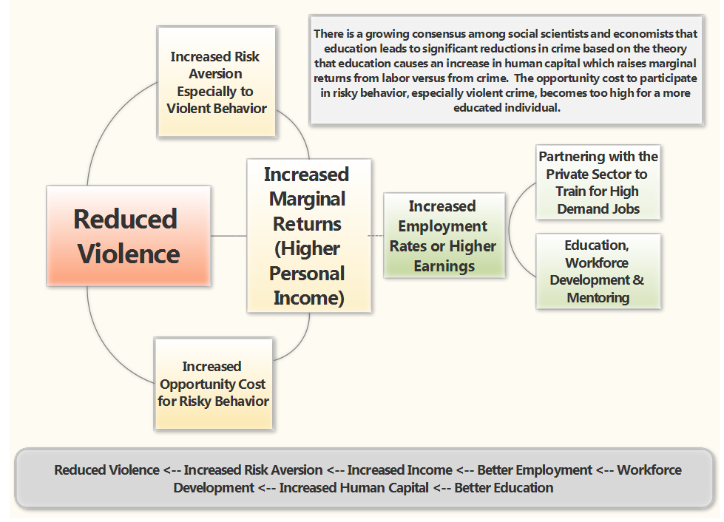
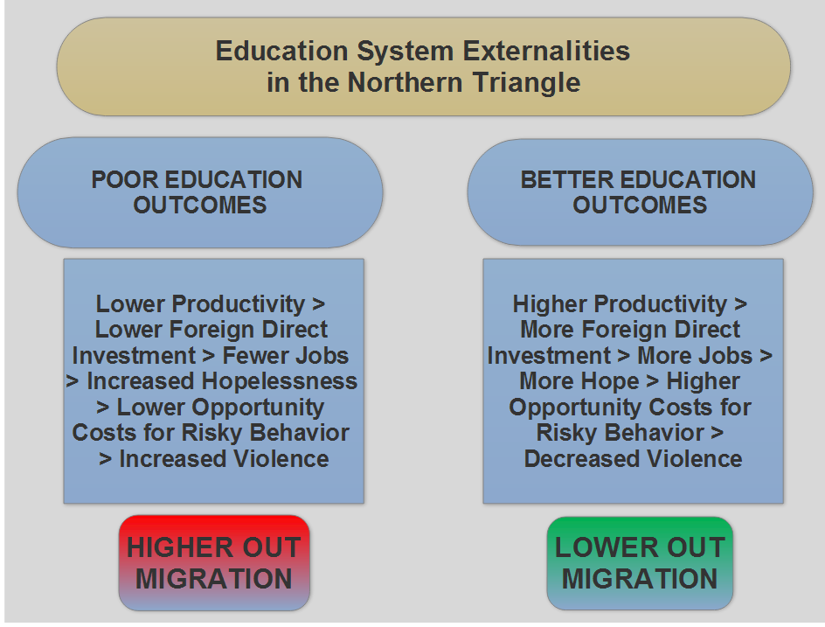

Guest workers would build economic nest eggs during the - year work period in excess of $25,000 which would only be provided to them upon return to their country of origin. Strengthened e-verification system in US would limit job opportunities for those Northern Triangle origin Hispanics that are not part of the Guest Worker program.

