A View from the Ruling Class
of the Mississippi Delta
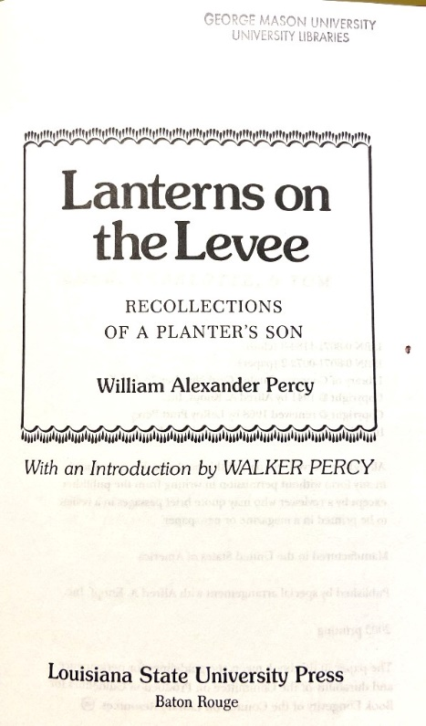
William Alexander Percy 1941 – Alfred A. Knopf
I inadvertently discovered “Lanterns on the Levee” while searching for a history of the South that described the economics of slavery, provided evidence of the economic stagnation it caused, and discussed its cultural impact. The book I sought was Hinton Helper’s “The Impending Crisis of the South: How to Meet It” published in 1857 which used data from the 1850 census to describe the lack of innovation, investment and equitable economic growth of the Antebellum South. Needless to say, Helper’s book was banned in the South prior to the Civil War. After the war a historical narrative was put forward that the economic and political leaders, the “planter class” had been the aristocratic nobility that had fought against the degradation of Southern culture and values. Their efforts were like those of the nobility of medieval times to care for and protect the peasants (poor and middle-class whites) and the slaves (blacks and mulattos). I first saw this theme in Erik Larson’s history of the start of the Civil War, “Demon of Unrest” in which the concept of chivalry promoted in Sir Walter Scott’s Waverly novels was central to manhood and honor in the South. An affront or insult to one’s honor could not be accepted, and acceptance of compromise was seen as weakness. Economics played a central role in this “honor system” with slavery being the most valuable commodity and its protection and expansion necessary for the survival of the South. The Civil War ensued with the loss of over 600,000 lives, the destruction of the South, and freedom for the slaves. My thought was, “How did that work out for you.” My next thought was – am I different? – at the end of the day, we all, all of us born and raised in Mississippi, are her sons. For good or bad, we need to confront our past and seek God’s redemption for we truly are his sons.
So, I found “Lanterns on the Levee” as an honorable mention for inclusion in “Fifty Books That Changed the South.” Its author, William Alexander Percy, was the cousin (and, I learned, the adoptive father of) Walker Percy, the historian who wrote a landmark, three-volume history of the Civil War. The theme of “Lanterns on the Levee” was familiar as the viewpoint of the elitist, faux aristocratic, upper class that represented the top-level of the South prior to the Civil War and beyond. Walker Percy loved his adoptive father but understood his views as expressed in the book were wrong and that we should take the best parts of a person we love and apply those to our life: “Surely it is the highest tribute to the best people we know to use them as best we can, not as their disciples, but ourselves.”
The prose in “Lanterns on the Levee” reflected the hubris of a class of people with a sense of self-importance that created disdain for the poor, whether Black or White. Percy made clear his thoughts about poor whites. It was his obligation to “teach and control” them. He wrote a letter to the New Republic at one point in the book to explain what a difficult job it was to administer this control, what with the Yankee press writing things that flamed racist outbursts in the South.
I am from the Hill Country of Mississippi, having been born on the edge of the Delta in Grenada, Mississippi, in 1952.

Bill Percy writes of poor whites: “I can forgive them as the Lord God forgives, but admire them, trust them, love them – never. Intellectually and spiritually, they are inferior to the Negro, whom they hate. At their door must be laid the disgraceful riots and lynching gloated over and exaggerated the world over. The Delta was not settled by these people; its pioneers were slave-owners and slaves.”

To me, Percy was a classic example of the elites who caused the Civil War and then walked away as if nothing had happened. According to him, they were descendants of the Norman conquers of England, and the poor whites were the Ango-Saxon trash. William the Conqueror’s victory at the Battle of Hastings in 1066 had set this cultural revolution in motion and became the foundation of Delta planter’s noble obligation to govern the rest of society. Of poor whites, Percy wrote: “The Delta was not settled by these people; its pioneers were the slave-owners and slaves.”

Percy wrote about his youth and life. He noted that “left on its own, death had a poor sense of selection.” He mentions men in the Delta: Charlie Scott in Rosedale, Sam Neill in Indianola, and the Farish family in Mayersville. How being a friend of the “right” people can open any door – referencing Wade Hampton III, he wrote: “… he was a friend of General Wade Hampton whose friendship was an accolade and a passport.” That friend was General Ferguson who was charged with embezzling levee management funds and then escaping to South America. The shame came not from stealing $20,000 but in running away. Ferguson eventually returned and was never tried for theft. He was, after all, part of the aristocracy.

In disagreeing with his views on race, politics and culture, I, nevertheless, appreciated his prose, especially when he wrote about the natural beauty of Mississippi and New England. Writing of New England, Percy described the coming of Spring: “The grace of New England elms, whiffs of lilacs, spring which came in May and for its tardiness came with intolerable rapture, the long winters with crystal storms and interminable widths of snow never the same color, the sound of puckered thaw like crabs feeding, walks around frozen ponds … with the red, winter sunsets which turned the bare branches amethyst and crimson.” Traveling to the West, he wrote of the Grand Canyon: “I almost died happy at the sight of it. It is God’s most personal creation; you fell he’s just walked off and is expected back at any moment.” Describing his hometown wrote: “There were lovely trees and crepe myrtles but where they grew was their business, there were flowers but no gardens. It was just a usual Southern town of that period, and its name was Greenville – a name without charm to me – I prefer Alligator or Rolling fork or Nitta Yuma or Rosedale.”

Percy attended the University of the South in Sewanee, Tennessee, spent a year after college traveling abroad, and then entered Harvard Law School. He wrote of Harvard that: “Our chief dispensation was conversation. It was a superior brand of talk we indulged in … I wonder if the most civilized form of entertainment is fated for extinction by man’s most effective mental opiate, the radio?”

Referring to Harvard, Percy stated, “Whatever ability I may have to reason in a straight line from premise to conclusion derives from the discipline of those three years …” Writing of another professor at Harvard, “As with all great teachers, his curriculum was an insignificant part of what he communicated. From him you didn’t learn a subject, but life. I suspect anyway the important things we learn we never remember because they become part of us, we absorb them.” Speaking of another professor, he wrote, “He had the gift of being informal without being intimate.” Of his father, he wrote: “Father was the only great person I knew, and he would not have been great without Mother.” They both died in 1937 within weeks of each other.

Percy’s father LeRoy Percy was a planter, prominent lawyer and U.S. Senator from Mississippi. He loved and respected his father but had a special relationship with his mother. Of her he wrote: “Everyone became a little more charming than the was meant to by God to be when she was around.” There was touching passage about a former teacher, a nun at the Catholic private school he attended as youth: “Miss Carrie had failed at everything – in painting, in poetry, in making money, in winning love, in dying easy. Yet she was one of the few successes I ever knew.” My impression from his narrative was that Miss Carrie had lived the life she wanted to live – one that was devoid of worldly success but one that fed her soul, that displayed her spirit and reflected a self-examined life – one truly worth living.

During his father’s campaign for the senate, Percy traveled the state with him and described a crowd in Blackhawk, Mississippi: “They were the sort of people that lynch Negroes, that mistake hoodlumism for wit, and cunning for intelligence … they were undiluted Anglo-Saxons.” In a letter to the New Republic he explained why the magazine should stop writing inflammatory articles about Southern racism: “We could afford to be indifferent to your misunderstanding wer it not that the inflammable, uneducated whites to whom the best part of our lives is spent controlling and teaching seize upon comments as excuses for their own excesses.” He later wrote: “White folks and colored folks – that’s what we were – and some of us were nice and some weren’t.”

Reflecting on Mississippi’s power structure, he wrote: “Property is a form of power. Some people regard it as an opportunity for profit, some as a trust; in the former it breeds hubris, in the lat latter, noblesse oblige.” I had heard this phrase before in Latin America from a friend who had both property and power, and with it he said his duty was to give back. It reminds me of Tennessee Williams’ line for Blanche DuBois in “A Glass Menagerie” where she explains: “I have always depended on the kindness of strangers.” This search for meaning, to answer the question -- “Who are you?” – was addressed toward the end of the book with this statement: “ … God descends and faces the wayfarer. He speaks three slow words: ‘Who are you?’ The pilgrim answers: “I am your son.” After all is said and done, we, who were born and raised there, are all sons of Mississippi. And I like that.

. “Books That Changed the South,” Robert Downs, University of North Carolina—Chapel Hill, 1977. The books on the list were chosen for their historical effect, not their literary merit. The list includes books published between 1624 and 1951.
Wade Hampton III was the largest slave owner in South Carolina and a leading figure in the secessionist movement in the South. He served in the Civil War and later became governor and senator from South Carolina. In 1897, his nieces accused him of sexual abuse when they were adolescents.

